

|  |  |  |
| --- | --- | --- |
| **Supervisor** | SIR HARIS | |
| **Batch** | **2302B1** | |
| **Group** | **B** | |
| **Serial No.** | **Enrollment Number** | **Student Name** |
| 1. | Student1453035 | ABUBAKAR |
| 2. | Student1453038 | HAFIZ MUHAMMAD ZEESHAN |
| 3. | Student1431517 | USMAN ALI |
| 4. | Student1452380 | MUHAMMAD ANAS |

**Problem Statement:**

FIRST FASHION is selling various types of fashion products. The company advertises

by distributing the pamphlets, advertising on television and so on. Due to rapid

development in internet field, the company decides to launch a website where people

will get all the information about the various products available with them easily.

**Requirement Specification:**

Requirement Specification:

The Web site is to be created based on the following requirements.

1) The Home Page should be created making use of Sections with a suitable

logo.

2) Home Page should contain details of fashion products with suitable images.

3) The site should display a menu which will contain the options for brief

introduction about the various fashion products available, location of the shop

and any other information if required.

4) The information should be categorized according to the brand names of the

products like if a User wants to see only “LAKME” products or any other

companies products then he/she can click on a Link/button/menu etc and can

see only that Brand products.

5) When a user selects any particular brand, a list of products for that brand will

be displayed

6) A brief summary of features of individual products should be displayed on the

Web Page along with the product but detailed Features should be stored in

Individual Word documents which can be downloaded or viewed by the User

who wishes to see the same.

7) The user should also be able to compare the various products of different as

well as similar brands.

8) There should be a “Contact Us” page which will have the Address of the

Company which is as follows and the mail address which when clicked will

invoke the local mail client from where they can send an email.

**ACKNOWLEDGEMENT:**

I am grateful to all of those with whom I have had the pleasure to work during this and other related projects. My Faculty (**Sir Haris Naseer**) has provided me extensive personal and professional guidance and taught me a great deal about the project.

**SYNOPSIS:**

First Fashion is a groundbreaking online platform that revolutionizes the world of fashion by bringing together style and creativity in a seamless and accessible way. This dynamic website serves as a one-stop destination for fashion enthusiasts, designers, and shoppers alike, offering a unique blend of trendsetting designs, personalized styling, and a vibrant fashion community.

At First Fashion, users are greeted with an intuitive and visually stunning interface that captures the essence of contemporary fashion. The website offers an array of features and functionalities tailored to cater to the diverse needs of fashion aficionados, establishing itself as a leading destination for fashion-forward individuals worldwide.

**SITEMAP**

**HOME**

Contact Us

Product

Brands

About

Gucci

ipes

Zara

Lake me

**WIREFRAMES**

**Navbar:**



**Home Page:**

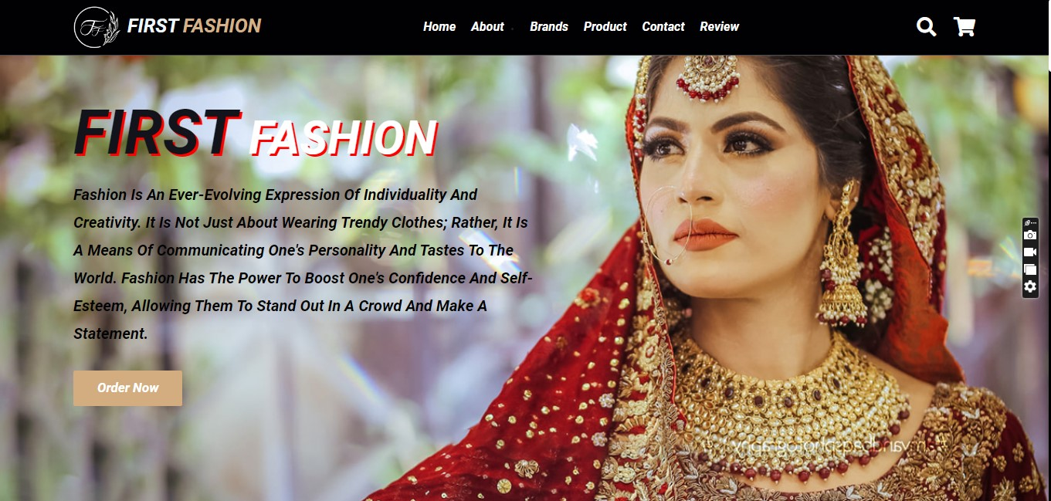

**Add to cart:**

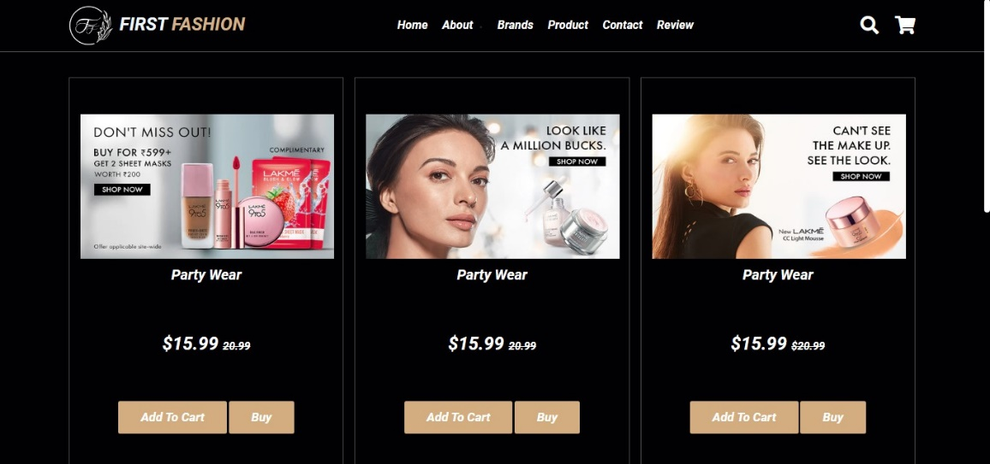

**Footer:**

